This lab exercise will give you hands-on experience with Knative for building, deploying, and managing serverless, cloud-native applications on Kubernetes.

Please follow the instructions here:
[Knavtive Serving and Eventing setup]
https://knative.dev/docs/install/yaml-install/serving/install-serving-with-yaml/
https://knative.dev/docs/install/yaml-install/eventing/install-eventing-with-yaml/
#Commands for your reference
minikube start --driver=docker --memory=15360 --cpus=8 --base-image=registry.k8s.io/kicbase/stable:v0.0.48 --kubernetes-version=v1.34.0
kubectl apply -f serving-crds.yaml
kubectl apply -f serving-core.yaml
kubectl get pods -n knative-serving
kubectl apply -f istio.yaml
kubectl get pods -A
kubectl apply -f net-istio.yaml
kubectl get pods -n istio-system
kubectl --namespace istio-system get service istio-ingressgateway
kubectl apply -f cert-manager.yaml
kubectl get pods --namespace cert-manager
kubectl apply -f eventing.yaml

[Knative Functions]
https://knative.dev/docs/getting-started/about-knative-functions/

Comments: 1. Use local registry; 2. Skip the "Deploying a function" part
#Commands for your reference
kn func version
func create -l go hello
kn func run
docker run -d -p 5001:5000 --name registry registry:2
func run --registry localhost:5001
func invoke
func build --registry locahost:5001
[Knative Serving]
https://knative.dev/docs/getting-started/first-service/
[Knative Eventing]
https://knative.dev/docs/getting-started/getting-started-eventing/

Please write a document with screenshots and notes for major steps and commit it to your github repo.

1. Setup & Verify
# Check installed toolsRun
docker version
minikube version
kubectl version --client
kn version

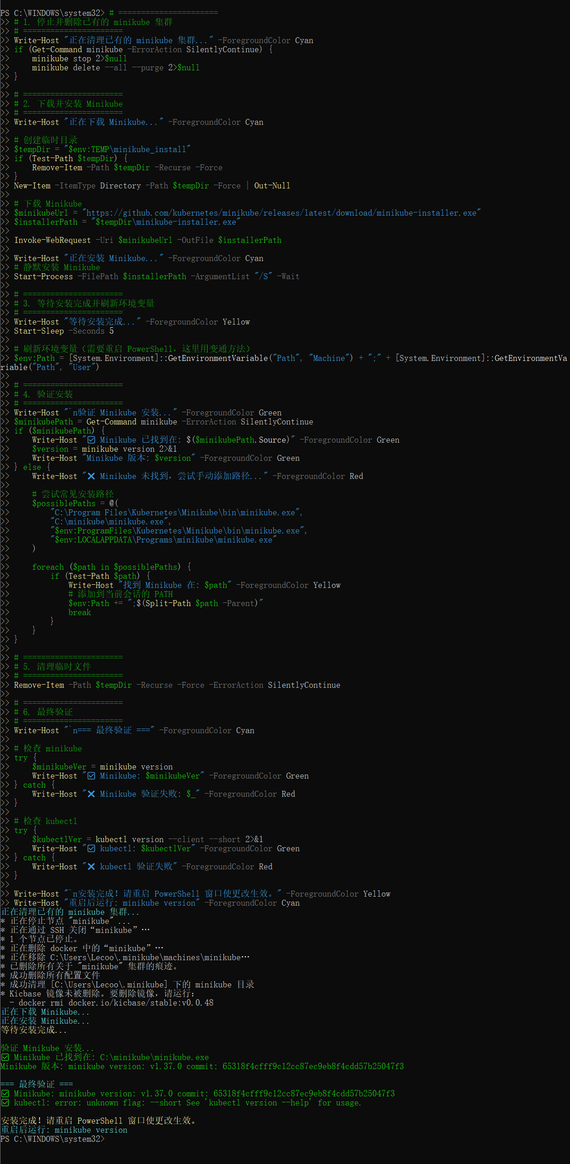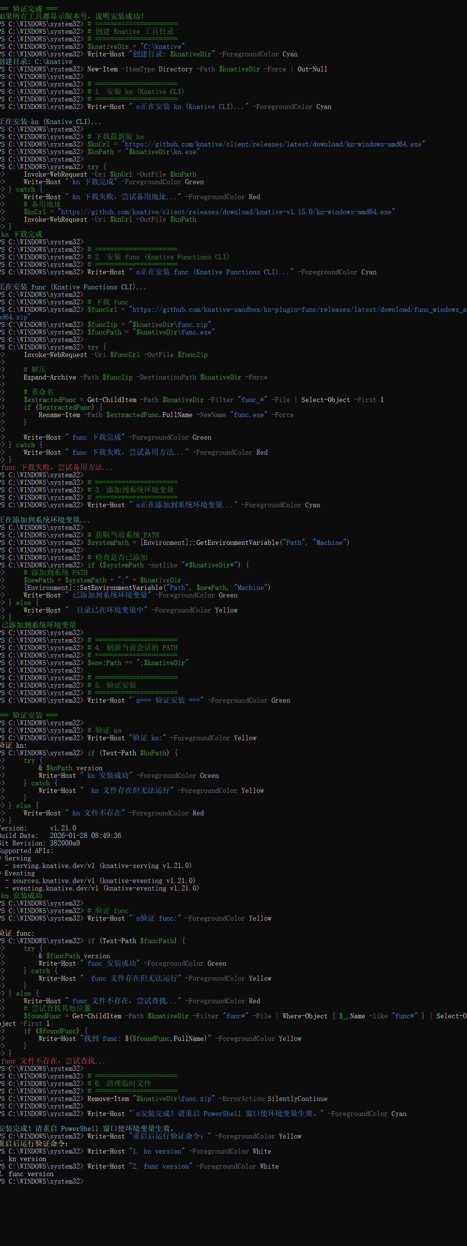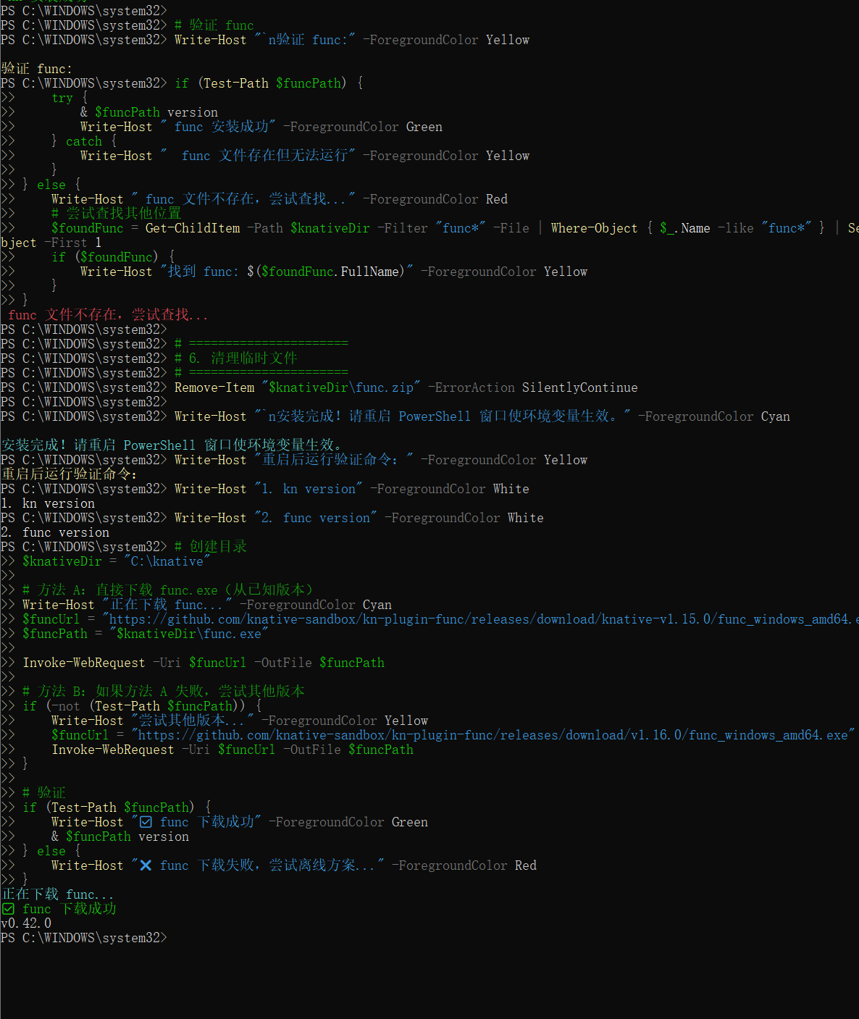

2. Create Cluster
# Create Kind clusterRun
kind create cluster --name knative-lab
kubectl get nodes
kubectl cluster-info

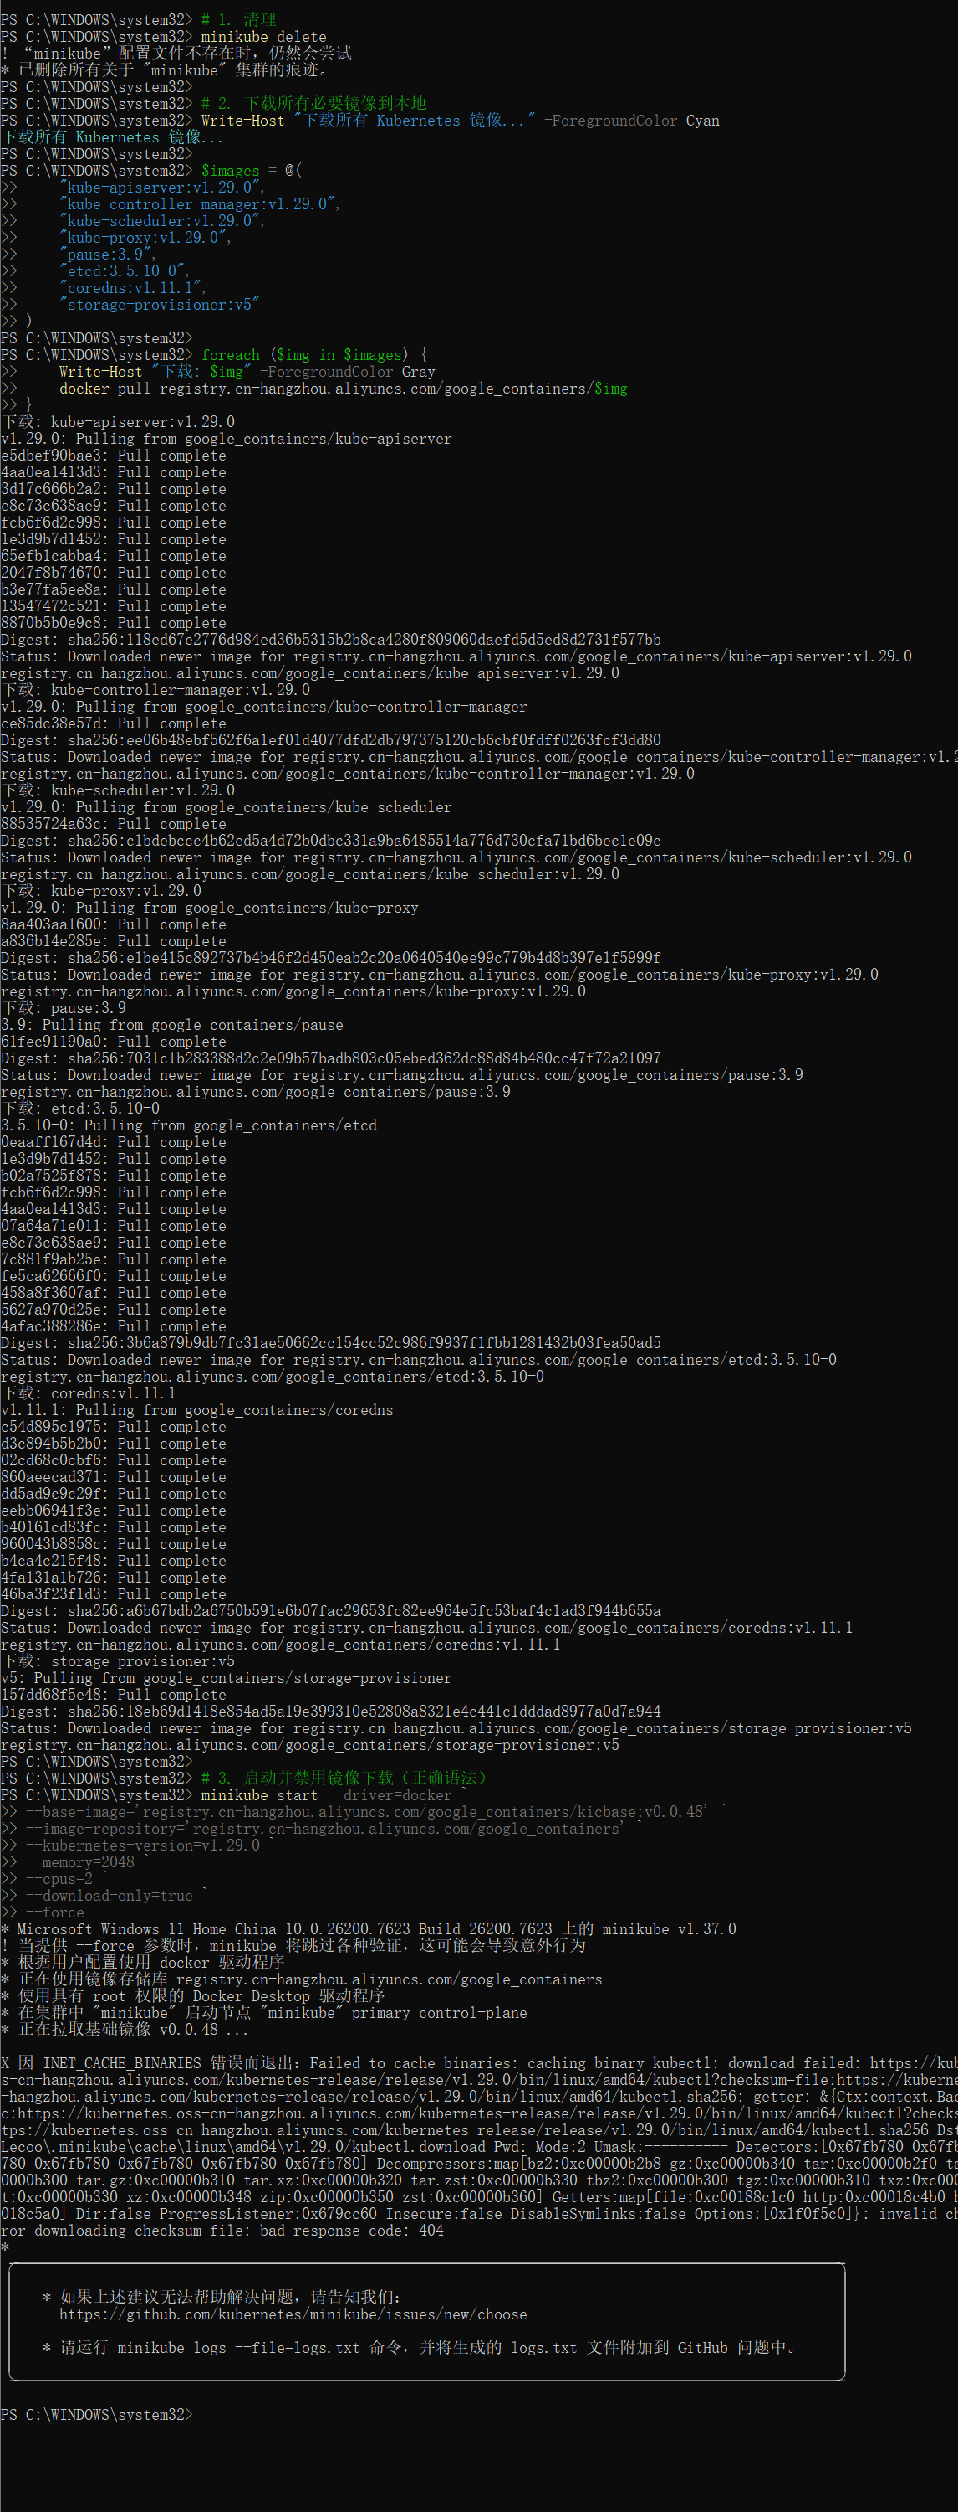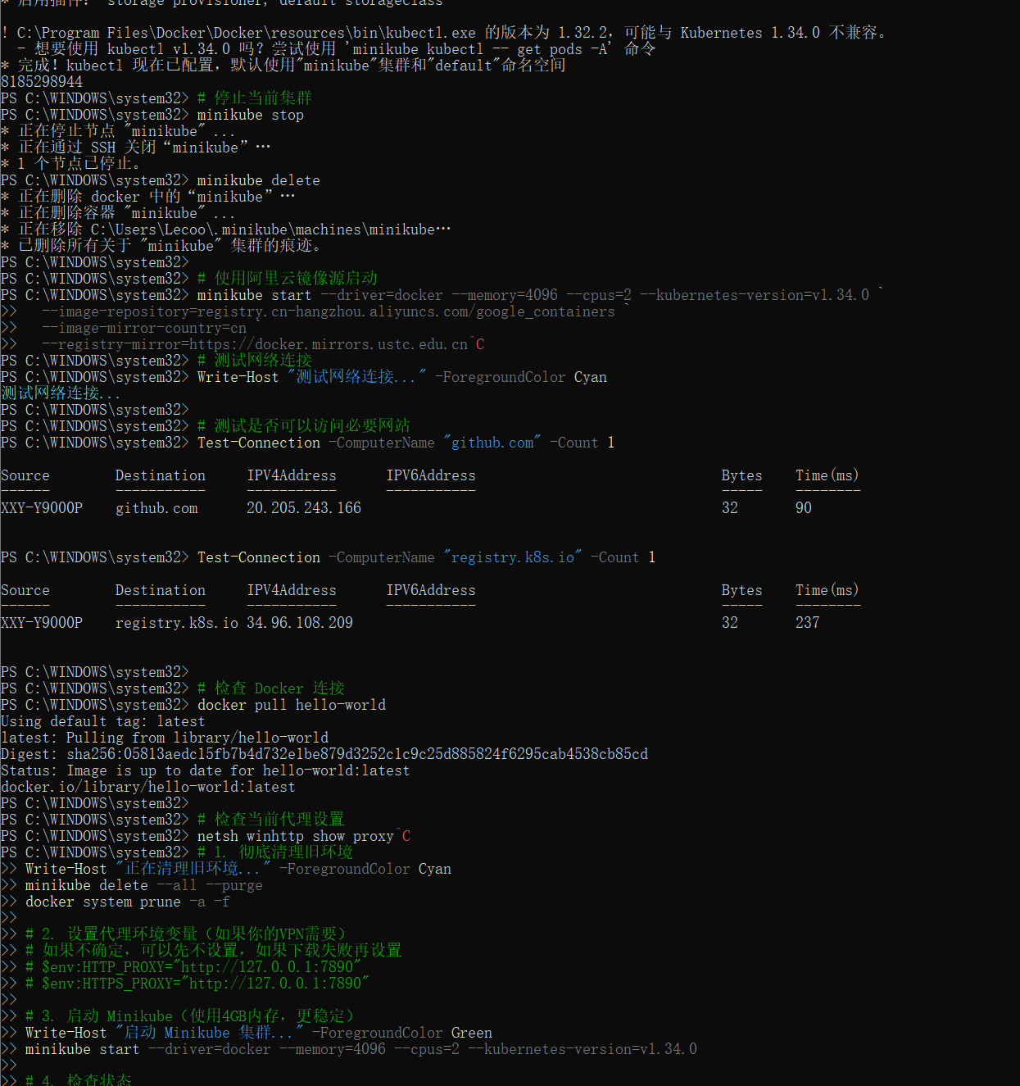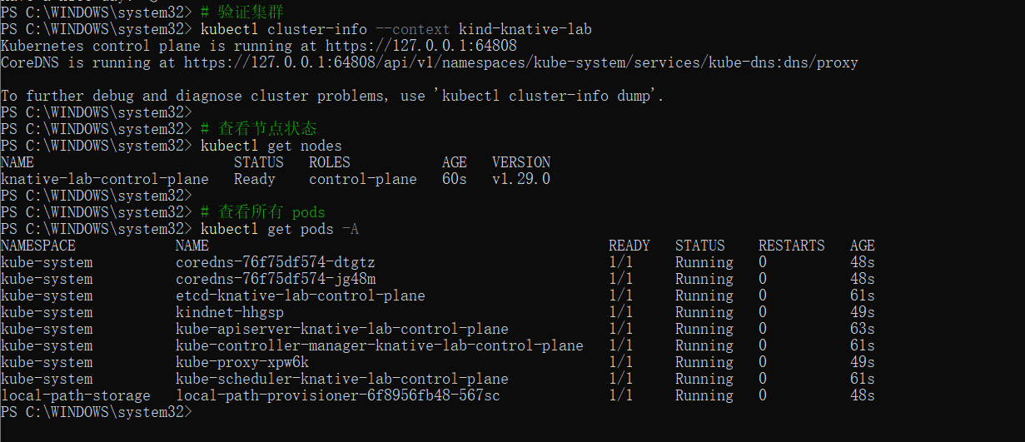

3. Install Knative
# Install Knative ServingRun
# Download files
curl -L https://github.com/knative/serving/releases/download/knative-v1.15.0/serving-crds.yaml -o serving-crds.yaml
curl -L https://github.com/knative/serving/releases/download/knative-v1.15.0/serving-core.yaml -o serving-core.yaml

# Install
kubectl apply -f serving-crds.yaml
kubectl apply -f serving-core.yaml

# Check
kubectl get pods -n knative-serving --watch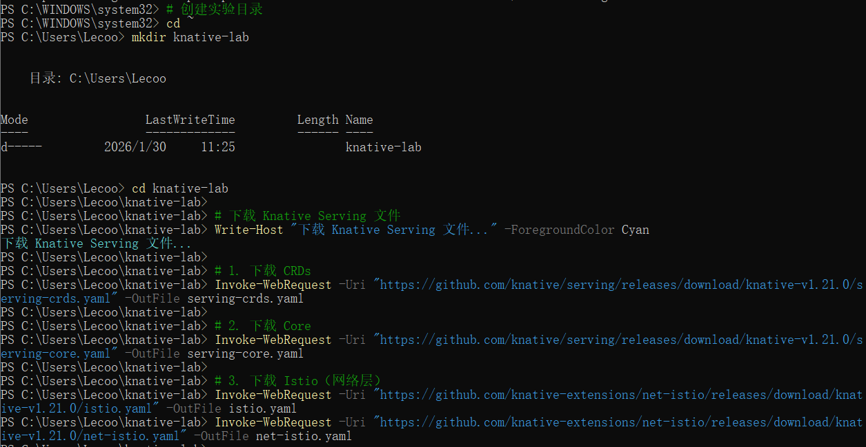

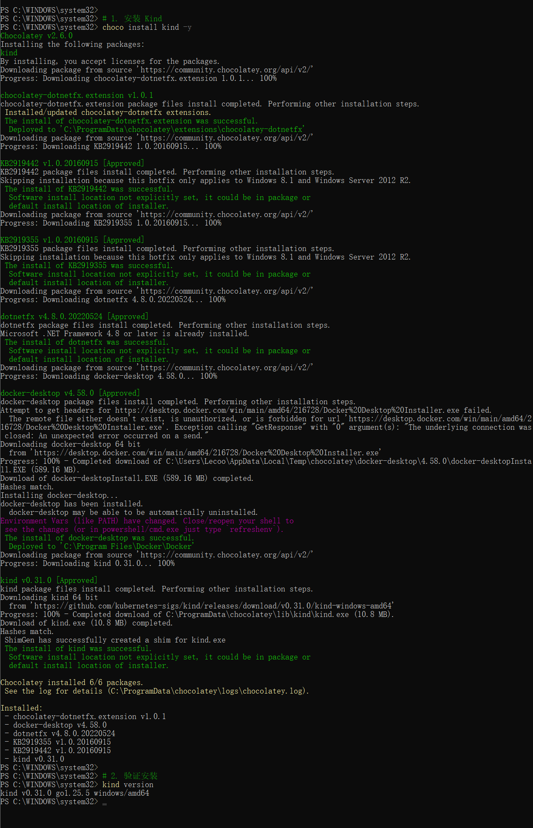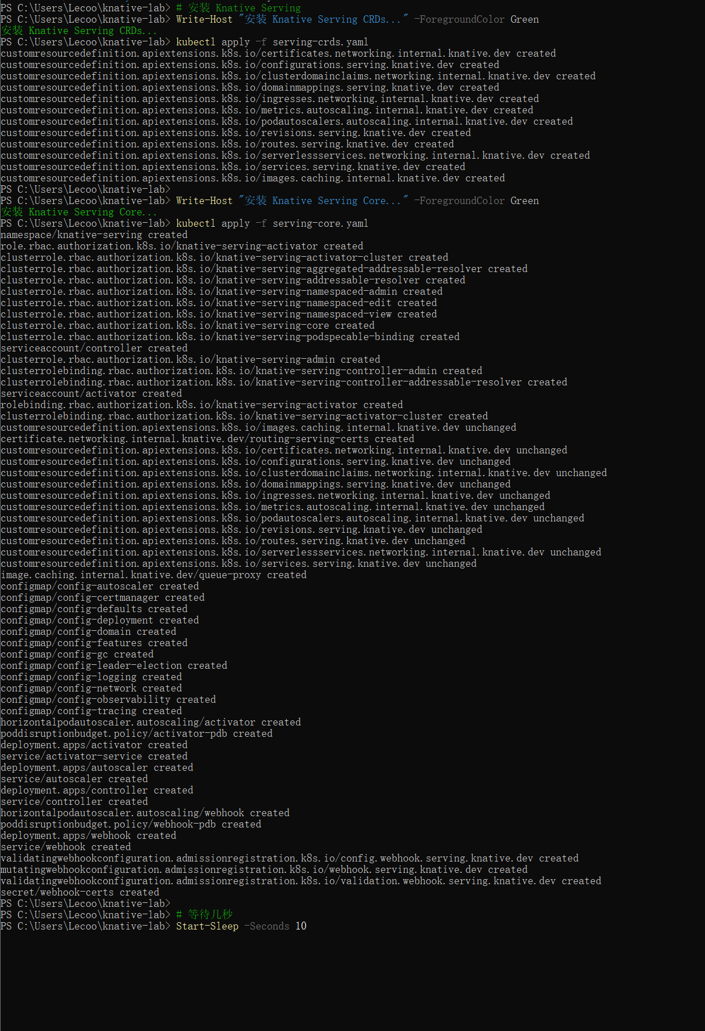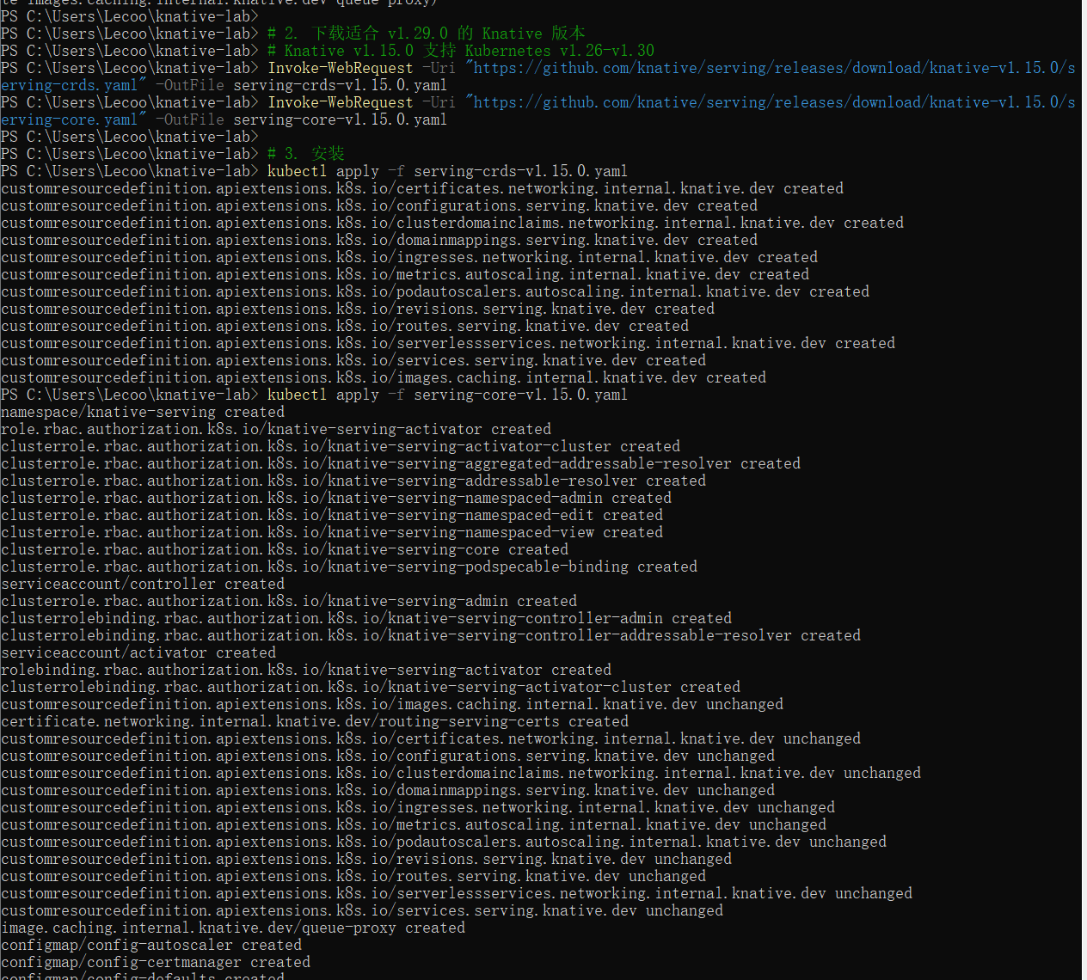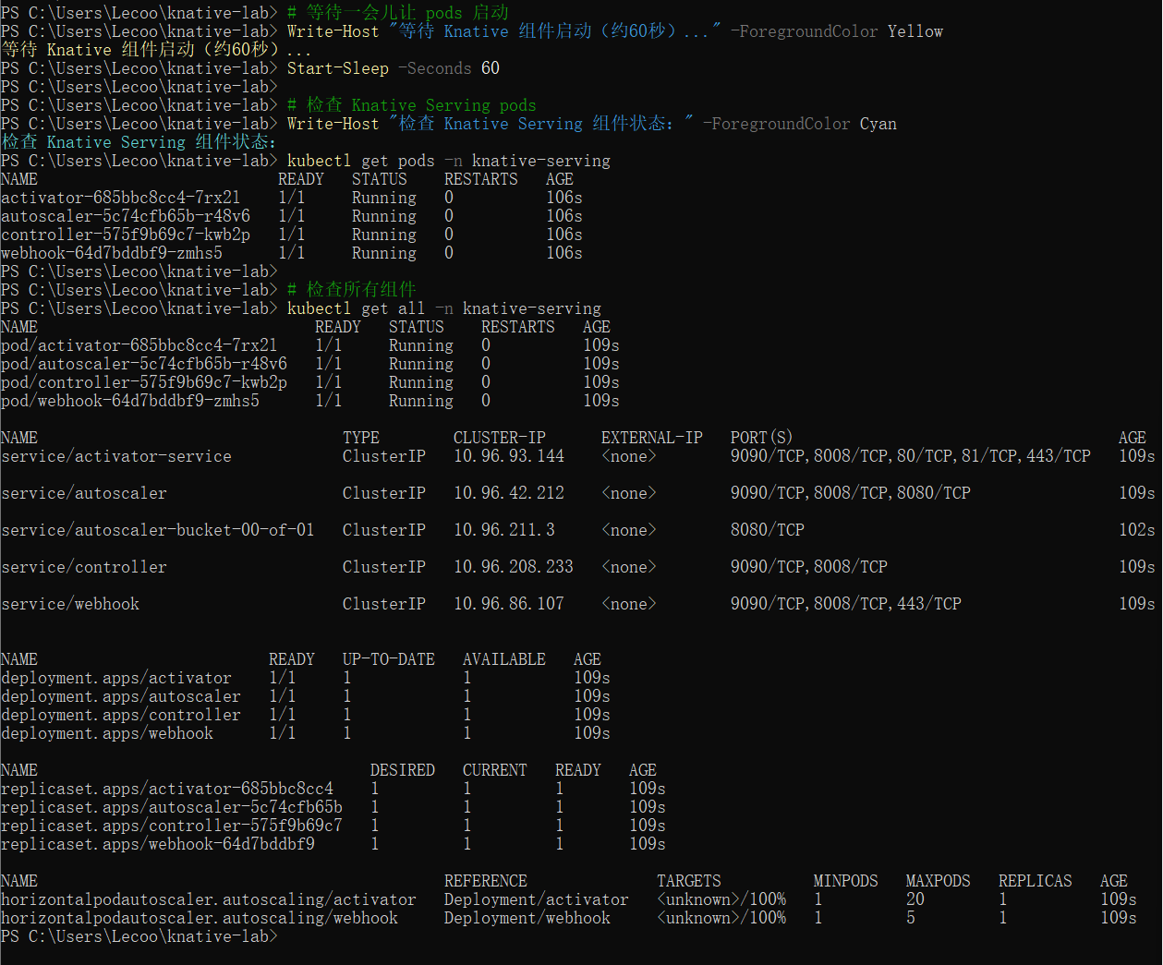4. Install Network (Istio)
# Install IstioRun
# Download Istio
curl -L https://github.com/knative-extensions/net-istio/releases/download/knative-v1.15.0/istio.yaml -o istio.yaml
curl -L https://github.com/knative-extensions/net-istio/releases/download/knative-v1.15.0/net-istio.yaml -o net-istio.yaml

# Install
kubectl apply -f istio.yaml
kubectl apply -f net-istio.yaml

# Verify
kubectl get pods -n istio-system

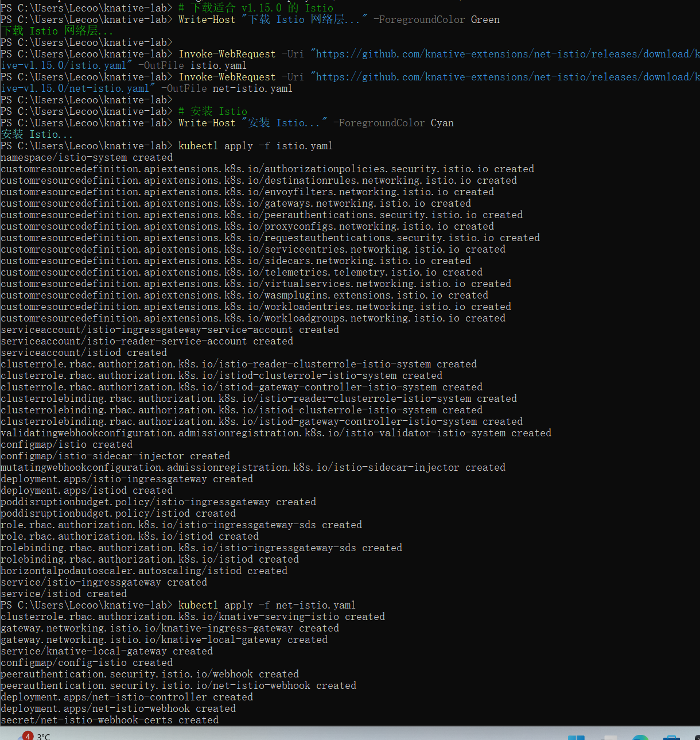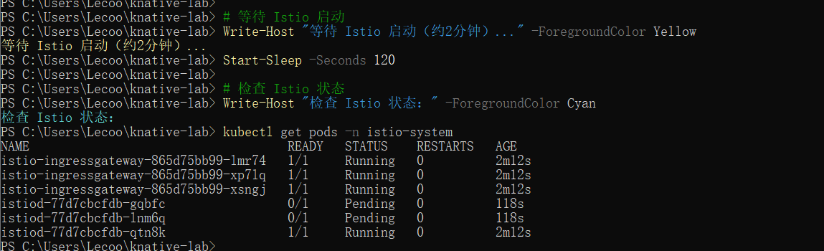5. Deploy Service
# Deploy Hello WorldRun
# Create service
cat <<="" pre="">

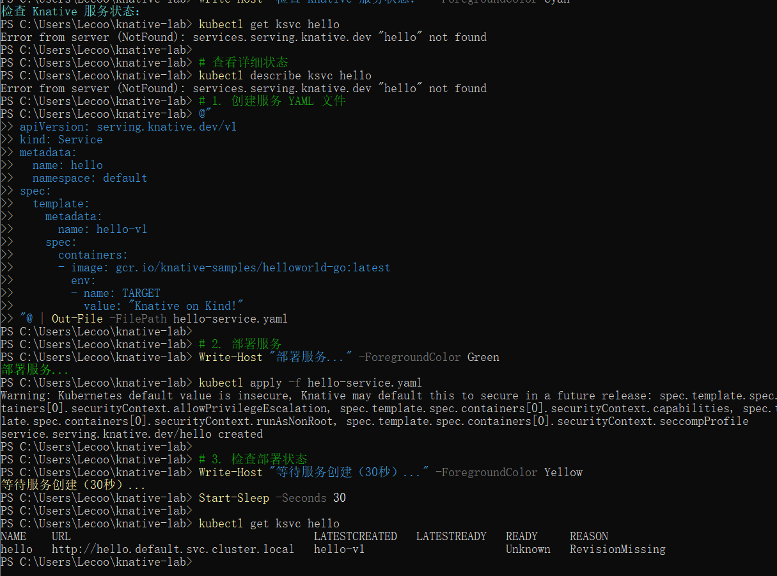

6. Verify Features
# Test Knative featuresRun
# Scale-to-Zero (no pods when idle)
kubectl get pods -l serving.knative.dev/service=hello

# Get service URL
kubectl get ksvc hello -o jsonpath='{.status.url}'

# See all components
kubectl get all -n knative-serving
kubectl get revisions

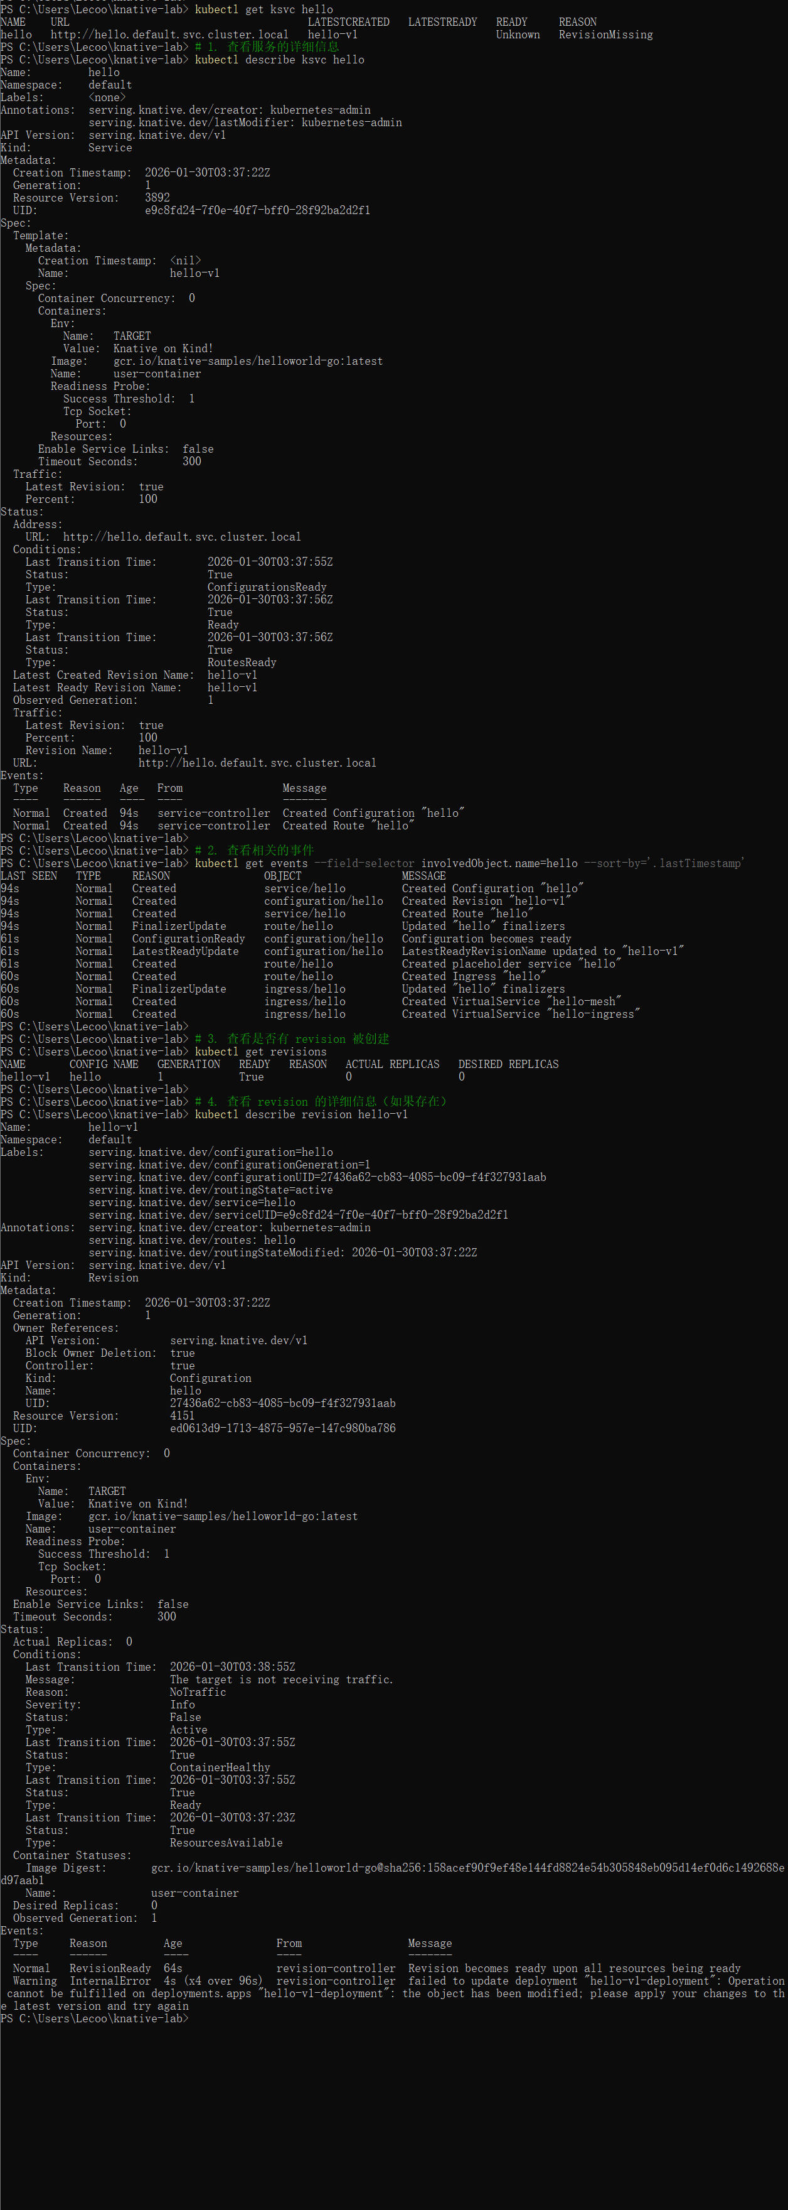7. Test Access
# Test the serviceRun
# Port forward for testing
kubectl port-forward -n istio-system svc/istio-ingressgateway 8080:80 &

# Send request
curl -H "Host: hello.default.example.com" http://localhost:8080

# Alternative: direct node port
INGRESS_PORT=$(kubectl -n istio-system get svc istio-ingressgateway -o jsonpath='{.spec.ports[?(@.name=="http2")].nodePort}')
curl -H "Host: hello.default.example.com" http://localhost:$INGRESS_PORT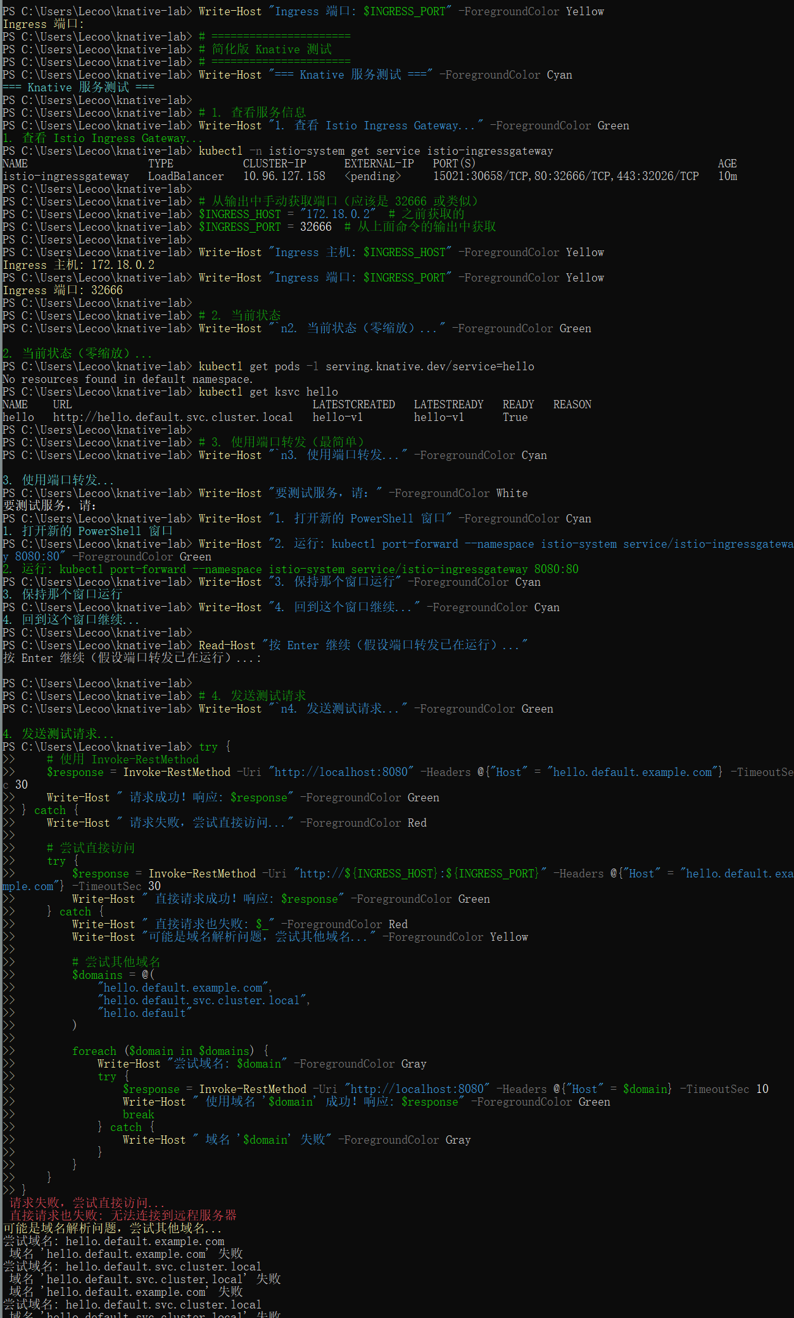

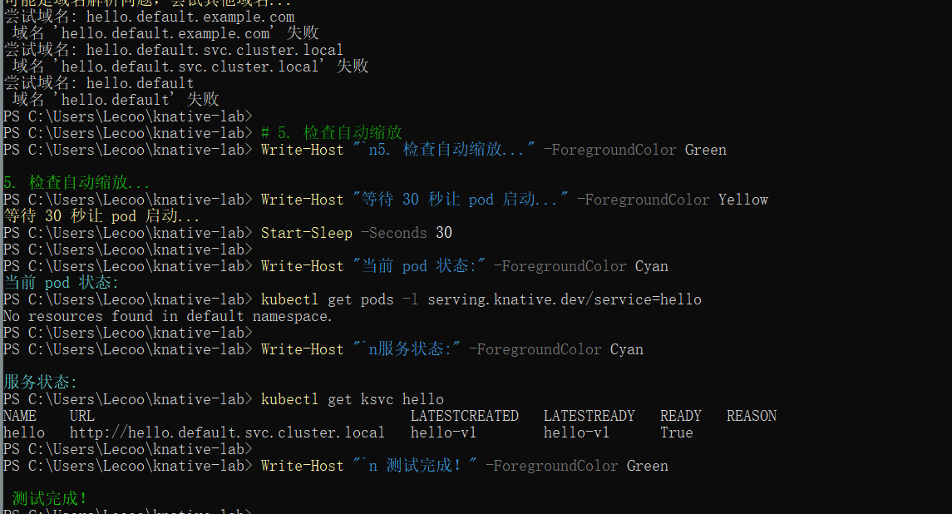8. Cleanup
# Clean resourcesRun
# Delete service
kubectl delete ksvc hello

# Delete Knative
kubectl delete -f serving-core.yaml
kubectl delete -f serving-crds.yaml

# Delete Istio
kubectl delete -f net-istio.yaml
kubectl delete -f istio.yaml

# Delete cluster
kind delete cluster --name knative-lab

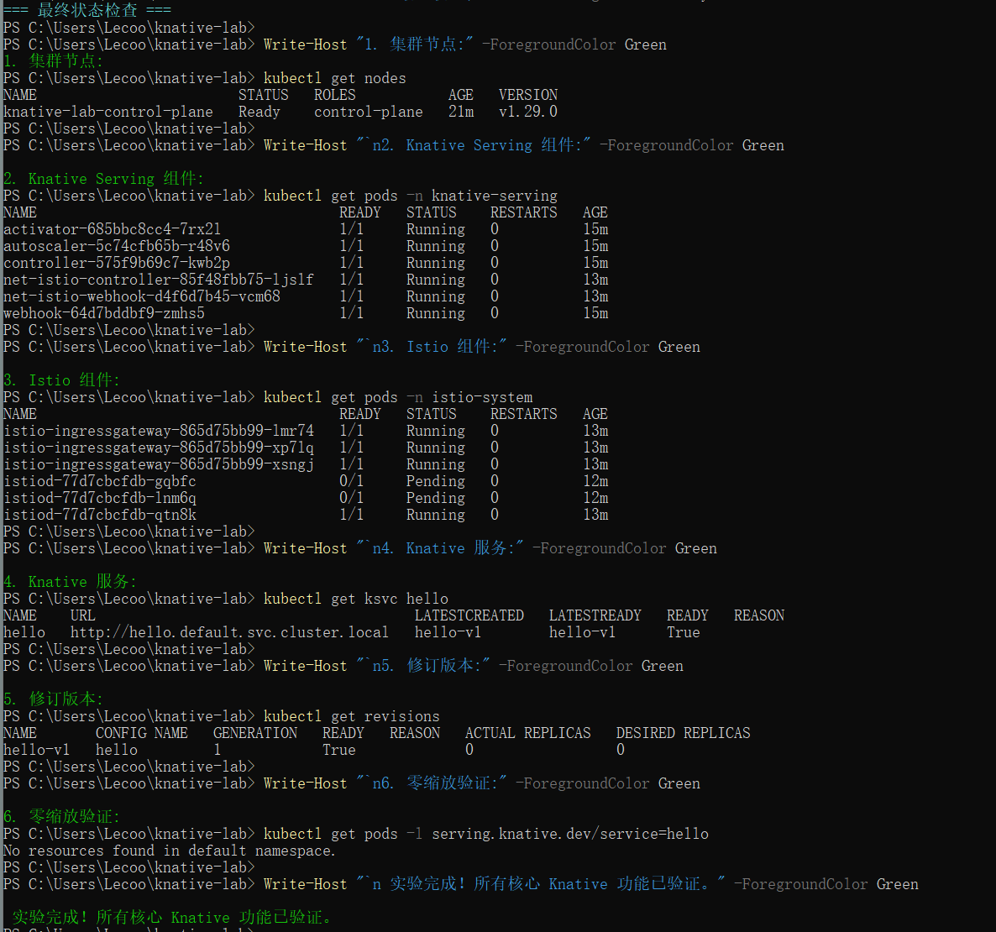✅ Summary
Completed:
- ✓ Cluster setup with Kind
- ✓ Knative Serving installation
- ✓ Istio network layer
- ✓ Service deployment
- ✓ Scale-to-zero verification
- ✓ Revision management

